**What is C ?**

1. C is a programming language
2. Developed at AT & T’s Bell Laboratories in USA in 1972.
3. Designed and Written by DENNIS RITCHIE.
4. Reliable , simple and easy to use language.
5. Case sensitive language(always in lower case)

**Steps in learning C programming:**

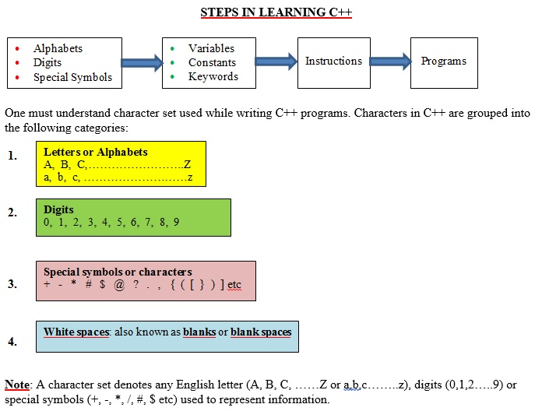

**CONSTANTS:**

.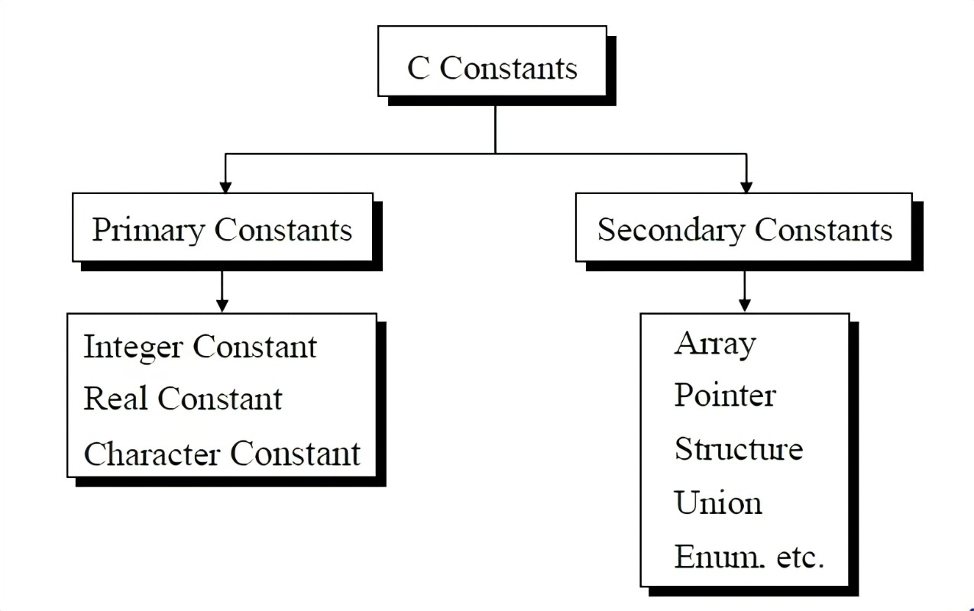

**Rules for Constructing Integer Constants**

(a) An integer constant must have at least one digit.

(b)It must not have a decimal point.

(c) It can be either positive or negative.

(d) If no sign precedes an integer constant it is assumed to be positive.

(e)No commas or blanks are allowed within an integer constant.

(f) The allowable range for integer constants is **-32768 to 32767.**

**Rules for Constructing Real Constants**

Real constants are often called Floating Point constants. The real constants could be written in two forms—Fractional form and Exponential form.

A real constant must have at least one digit.

It must have a decimal point.

It could be either positive or negative.

Default sign is positive.

No commas or blanks are allowed within a real constant.

Ex.: +325.34

426.0

-32.76

-48.5792

**Keywords:**1.Words whose meaning has already been explained to compiler.

2.Only 32 keywords available in c.

3.Also known as “Reserved words”.

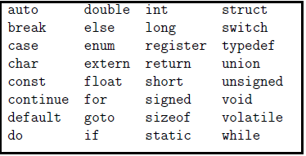

**Variables:**

An entity that may vary during program execution is called a variable.

**Rules for Constructing Variable Names**

1. A variable name is any combination of 1 to 31 alphabets, digits or underscores. Some compilers allow variable names whose length could be up to 247 characters. Still, it would be safer to stick to the rule of 31 characters. Do not create unnecessarily long variable names as it adds to your typing effort.
2. The first character in the variable name must be an alphabet or underscore.
3. No commas or blanks are allowed within a variable name.
4. No special symbol other than an underscore (as in **gross_sal**) can be used in a variable name.

Ex.: si_int

m_hra

pop_e_89

**Where to write C programs?**

EDITOR—> COMPILER—--->OUTPUT

(write the program) (converts into

machine language)

IDE: Integrated Development Environment

This consistrs of an editor as well as compiler.

**Writing C program:**

**main():**\* A function  
* All statements under this has to be enclosed by {}.

* Always returns integer value.

* So we write int main().

* Integer value returns 0. 0 means success.

**printf():**

Library function ;shows output.

**#include:**

Its a preprocessor directive.

**Format specifiers:**

